**100**

Critical Access   
**TOP HOSPITAL**  
2024

HOSPITAL NAME

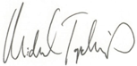

Michael Topchik, National Leader, The Chartis Center for Rural Health