**100**

Rural & Community   
**TOP HOSPITAL**  
2023

HOSPITAL NAME

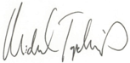

Michael Topchik, National Leader, The Chartis Center for Rural Health