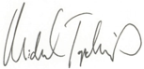

CATEGORY

Executive Director, Chartis Center for Rural Health

Top Quartile Performer Category

HOSPITAL NAME

PERFORMANCE

LEADERSHIP

AWARD 2024